Firmware Update Operation:

1. Install the firmware update program with the file “DMR Firmware Download(User English) Setup v3.06’’ and run the program.

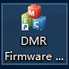 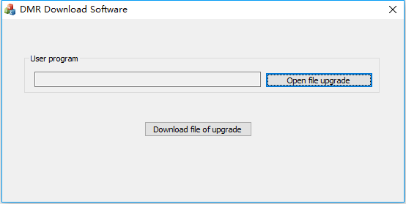

1. Connect the radio to the computer with the programming cable, press and hold PTT + SK1 when turn on the radio, the radio will go into update mode and the Rx/Tx signal light will flash green and red.

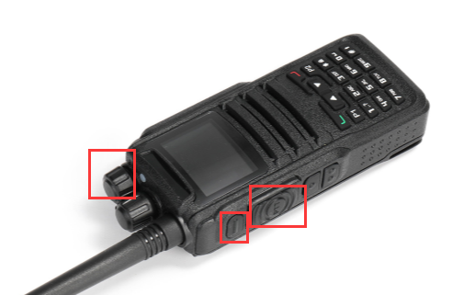

1. Click “Open file upgrade’’ and select the firmware file DM-1701(CSV)-V02.02.bin, then “Download file of upgrade”.

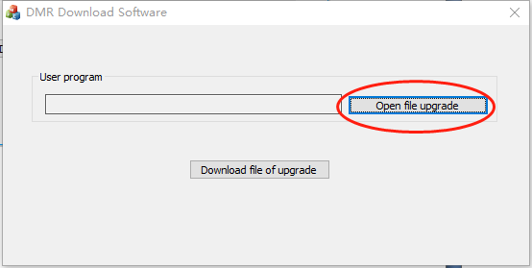 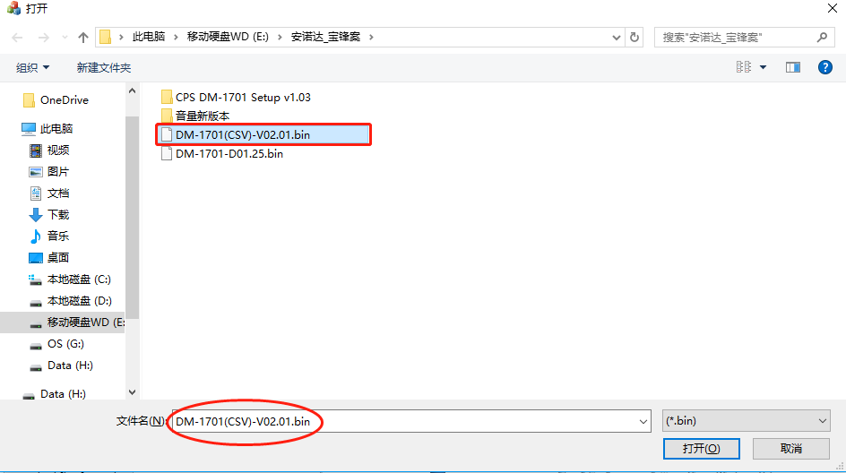

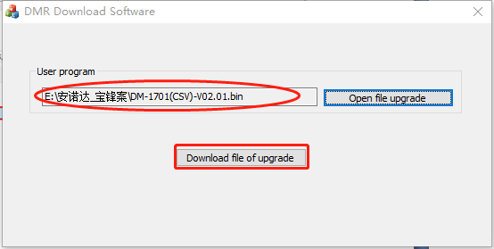

1. After it shows ‘’Download upgrade file successful’’, reboot the radio and the update is finished.

